CS375 Homework Assignment 4-2 (19 points)
Due date: 10/09/2026

- Given the following regular grammar:
S → aS | aI | bJ, I → bK | aI, K → aK | bJ, J → aJ| bJ | Ʌ

one can use the algorithm given in slide 39 of the notes “Regular Languages and Finite Automata- IV” to construct an NFA to recognize the language of that grammar. Fill out blanks in the following figure so that the resulting NFA would fulfill such a task, i.e., would recognize the language of the given grammar. (4 points)
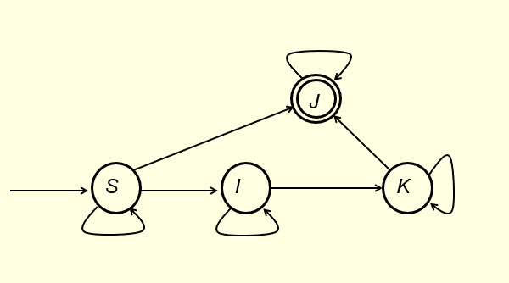

2. Fill out the following blanks to make it a regular grammar with S being the start symbol for the following given regular expression:
c*d*a* + b (5 points )

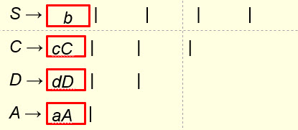

3. Using Pumping Lemma (slides 46-52 of the notes ‘Regular Languages & Finite Automata-IV’) one can show that the language L= {$a^{n}b^{n}$ | n ϵ N } is not regular (We need this property in the next Chapter). This is done by way of contradiction. We assume L is regular. Since L is infinite, Pumping Lemma applies. We then consider the string $s=a^{m}b^{m}$ where $m$ is the number of states in the DFA that recognizes L. Since the length of $s$ is bigger than $m$, by Pumping Lemma, there exists strings $x, y and z$such that $s=xyz$, $y≠Λ$, $\left|xy\right|≤2m$ and $xy^{k}z∈L$ for all $k∈N$. If $\left|xy\right|<2m$ then the first repeated state on the acceptance path cannot be a final state. This statement is not true, why? (2 points)

4. Fill out the following blanks to make it a context-free grammar for the given language over the alphabet {a, b}: { a^{2n+3}b^{3n} | n >= 0} (2 points)

S → |

5. Fill out the following blanks to make it a context-free grammar for the given language:
{ a^{n+3} b^{2n} | n >= 0 } { a^{2n}b^{n+3} | n >= 0 } (2 points)

S → AB, A → | , B → |

6. For the PDA’s shown in Fig. 1 and Fig. 2, which one/ones or no one would accept the language $L=\left\{x∈{\left\{a, b\right\}}^{*} \right| N_{a}\left(x\right)={1+N}_{b}(x)\}$ by empty stack? Use the execution of the string babaa to justify your answer. You need to create/use your own text boxes for your work in the tables. (4 points)

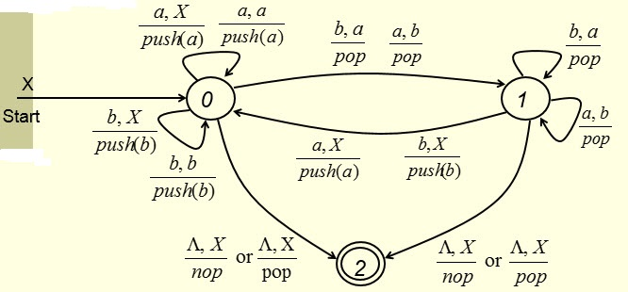
Fig. 1

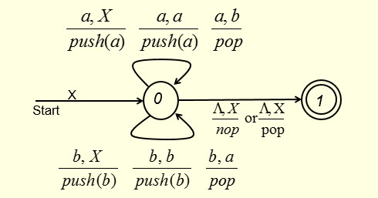
Fig. 2

Sol.
For the PDA in Figure 1, we have For the PDA in Figure 2, we have

(0, babaa, X)

(0, babaa, X)

- Solutions must be typed (word processed) and submitted both as a pdf file and a word docx file to Canvas before 23:59 on 10/09/2026.
- Don’t forget to name your files as

CS375_2026f_HW4-2_LastName.docx / CS375_2026f_HW4-2_LastName.pdf

