CS375 Homework Assignment 3 (40 points)
Due Date: Sept. 25, 2026

- (8 points)
To transform the following NFA to a regular expression,
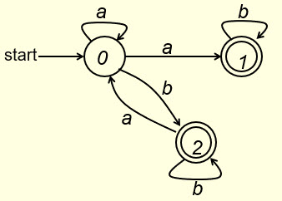
we first connect a new start state s to the start state of the given NFA and connect each final state of the given NFA to a new final state f as follows.

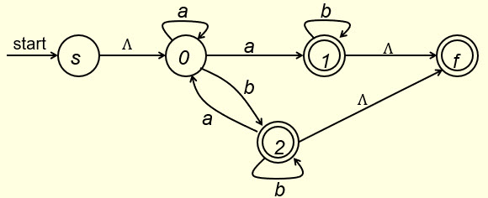

If we eliminate state 1 first, the modified NFA becomes of the following form. Fill out the blank in the following figure. (1 point)
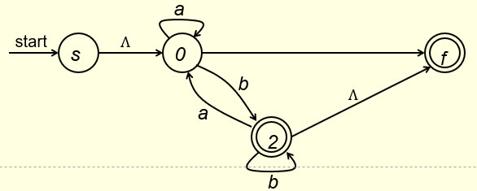

If we eliminate state 2 then, we get the following NFA. Fill out the blanks below. (5 points)
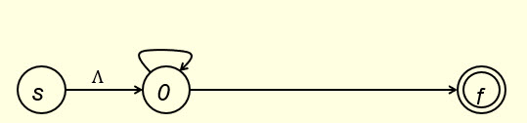

By eliminating state 0 we get the following NFA. Fill out the blank below. (2 points).
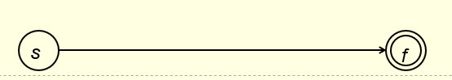

The expression in the above box is the regular expression of the given NFA.

- (11 points)
In Question #1, instead of eliminating states of the given NFA in the order of 1, 2 and 0,
if we eliminate state 0 first, we get the following NFA. Fill out the blanks in the following figure. (6 points)
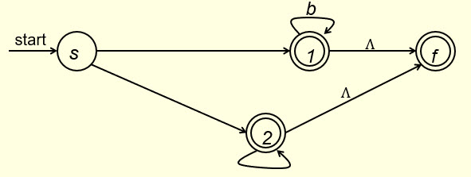

If we eliminate state 1 then, we get the following NFA. Fill out the blanks the figure (only the new one will be graded. (1 point)
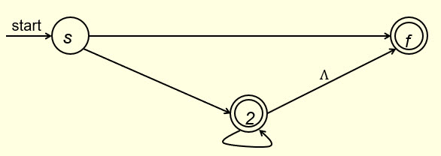

By eliminating state 2, we get the following NFA. Fill out the blank in the figure. (4 points)
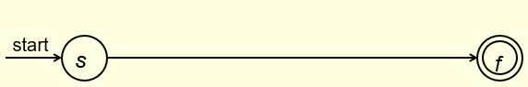

This expression should be the same as the one you get for Question #1. If your result here is different from your result for Question #1, your result for Question #1, or your result for Question #2, or even both maybe wrong.

- (9 points)
Given the following NFA over the alphabet {a, b},
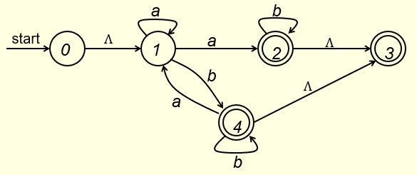
to transform it to a DFA, first construct Ʌ-closures of the states of the NFA. Fill out the blanks for state 0, state 1, state 4 and Φ below. (2 points)
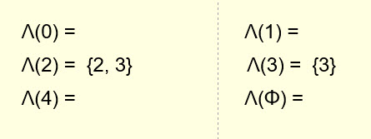

Next，to get the states of the DFA, we construct a tree as follows. Fill out the blanks in the following tree. (5 points)
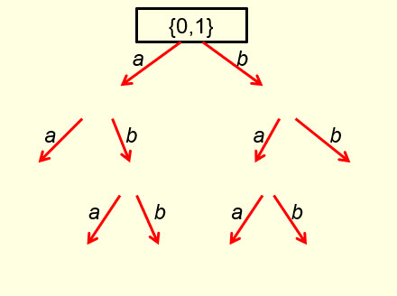

Distinct nodes in the above tree are listed below (for each level, nodes are taken from the tree from left to right). Fill out the blanks. (2 points)
{0,1}

- (12 points)
The above states are the states of the DFA to be constructed for the NFA given in Question #2. We have the following transition table for this DFA. Fill out the blanks in the table. (4 points)
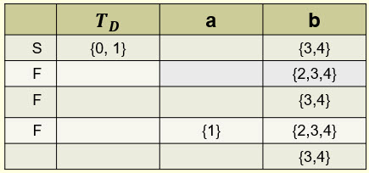

Now replace the five states from top down with 0, 1, 2, 3 and 4, respectively, the transition table of the DFA is of the following form. Fill out the blanks in the table. ( 4 points)
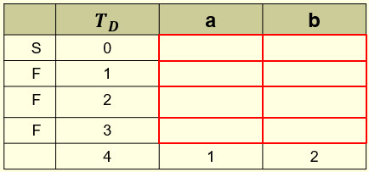

Hence, a DFA can be constructed as follows. Fill out the blanks in the DFA. (4 points)

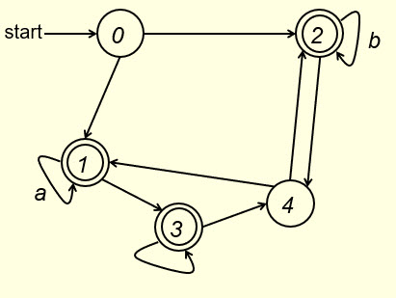
Regular expression of this DFA equals regular expression of the NFA given in Question 1. Another way to see this is: a string that can be accepted by this DFA if and only if that string can be accepted by the NFA given in Question 1.

- Solution must be typed (word processed) and submitted to Canvas both as a pdf file and a word document before 23:59 on 9/25/2026.
- Don’t forget to name your files the following way:
CS375_2026f_HW3_LastName.docx / CS375_2026f_HW3_LastName.pdf

