CS375 Homework Assignment 2 (40 points)
Due Date: Sept. 10, 2026
(The red boxes are text boxes. You can put your answers into the boxes directly)
- (6 points)
For each of the following regular expressions find a language (i.e., a set of strings) over A = {a,b,c} that can be represented/described by that expression. Show your work to get partial credit.
a. $a+bc$ b. $ab^{*}+c$ c. $aba^{*}+cb^{*}$
a. L(a+bc) =

b. L($ab^{*}+c)=$

c. L($aba^{*}+cb^{*})=$

- (2 points)
Find a regular expression to describe the following language.
$\{ a, aba, ababa, …, {\left(ab\right)}^{n}a, … \}$

- (4 points)
Find a regular expression for the following language L over the alphabet {a, b} with each string’s cardinality being a multiple of 3.

$L=\left\{ w \right| w∈{\left\{a, b\right\}}^{*}, \left|w\right|=3n for some n∈N\}$

- (4 points)
If a regular expression for the language over the alphabet {a, b} with no string containing the substring aa is (b+ab)*(Ʌ+a), then what is the regular expression for the language over the same alphabet but with no string containing the substring aaa?

- (4 points)
The following proof shows that
a(a + b)* + aa(a + b)* + a(a + b)* = a(a + b)*
Put the reason for step 1 and step 3 in the blanks to the right of these steps. If an example in the notes can be used for a step, quote that example.
a(a+b)* + aa(a+b)* + aaa(a+b)*

= a(a+b)* + (aa+aaa)(a+b)*
= a(a+b)* + a(a+aa)(a+b)*

= a(a+b)* + aa(a+b)*
= (a+aa)(a+b)*
= a(a+b)*

- (4 points)
Fill out the blanks in the following figure to make it a DFA that recognizes the expression a + ba*b. The alphabet is {a, b}.
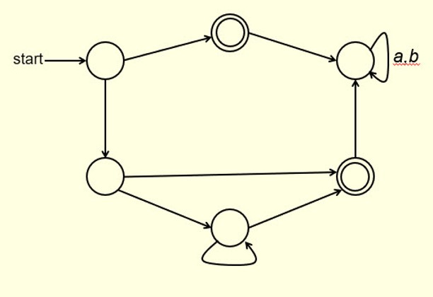

- (4 points)
Fill out the blanks in the following table to make it the transition function of the given NFA.

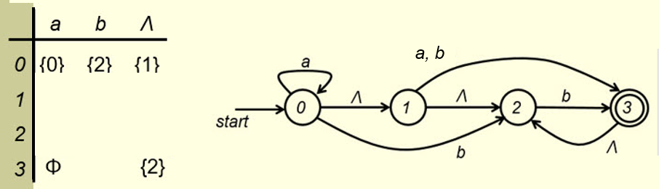

- (4 points)
Fill out the blanks in the following figure to make it an NFA for the expression b* + a*b* + a(a+b)*. The alphabet is {a, b}. If the expression can be simplified, simplify it first.
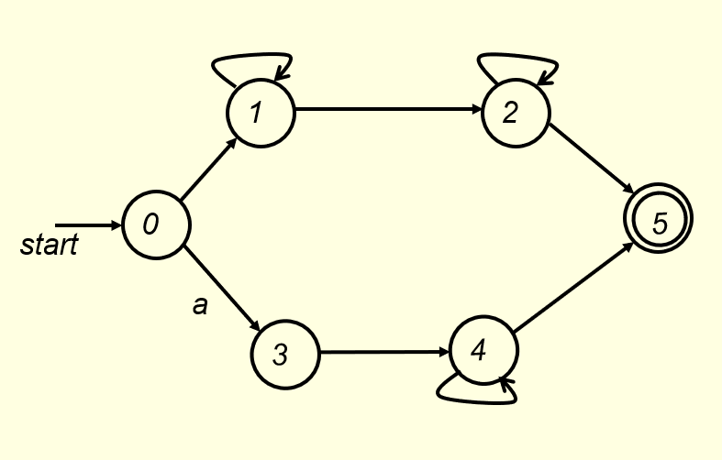

9. (8 points)
Fill out the blanks in the following figure to make it a DFA for the expression a*bc* + aac + ac. The alphabet is {a, b, c}.
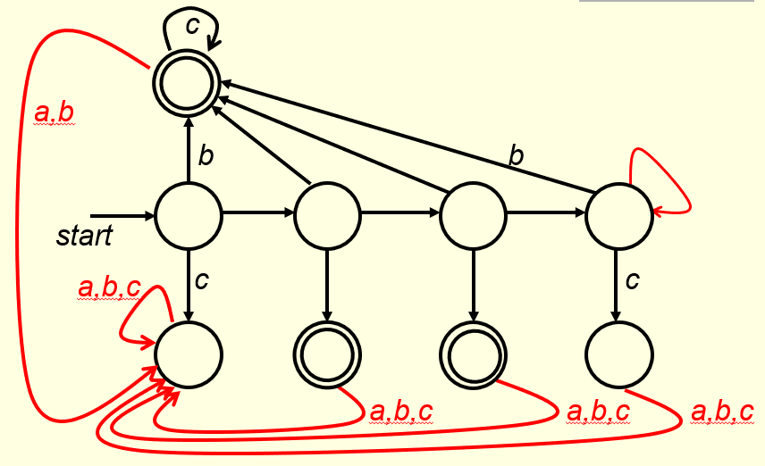

- Solutions must be typed (word processed) and submitted to Canvas both as a pdf file and a
word doc file before 11:59pm on 09/10/2026.
- Please name your files the following way:
CS375_2026f_HW2_LastName.docx / CS375_2026f_HW2_LastName.pdf

