**CS 535 Computer Graphics**  
**Homework Assignment 1 (40 points)**

**Due: 9/5/2025**

1. Given the following simple two-color raster scan system (a frame buffer with 8 x 8 entries, an image controller (also called a display processing unit (DPU)) and an LCD display with a resolution of 8 x 8 pixels)

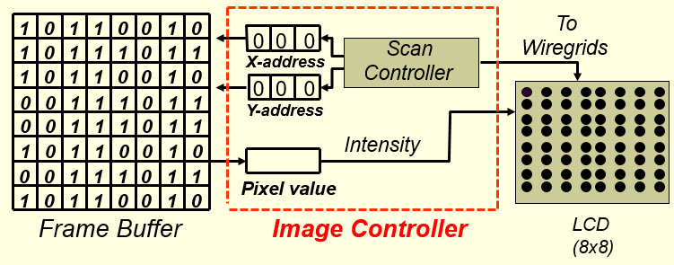

if the refresh rate is 120 Hz (meaning the screen will be refreshed 120 times per second), then

1. after the first 5/960 seconds, how would the screen look like, the one shown in (a), (b),(c), or, none of these? (4 points)
2. after the first 9/480 seconds, how would be screen look like, the one shown in (a), (b), (c), or none of these? (4 points)

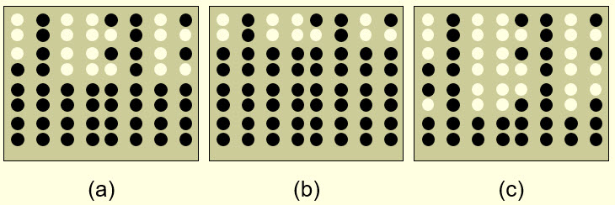

1. What is the main difference between the *event mode* and the other two input modes (*request mode* and *sample mode*)? Why? (4 points)
2. A modern*optical mouse* does not have to be operated on a special pad, it can be operated on any surface. Given a piece of black glass and a piece of transparent glass, equally smooth, a modern optical mouse would do better on the transparent glass. Why? (4 points)

1. In the following figure, what are the functions of the ITO film, the Orientation film and the Color filter ? You have to do a little research here. (10 points)

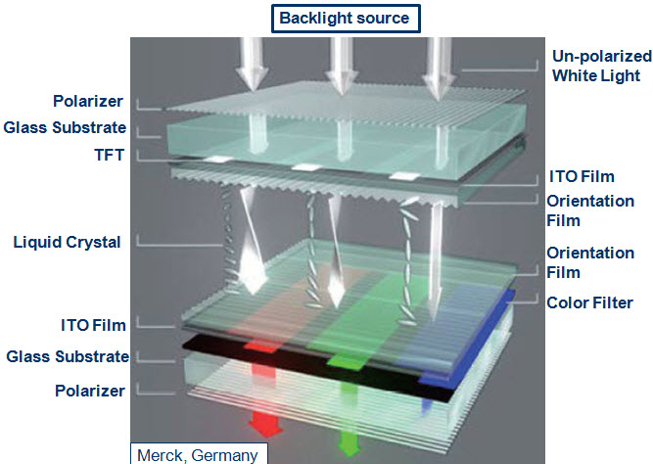

1. In a transmissive Liquid-crystal Display (LCD), if we remove the vertical polarizer layer from the LCD, what would happen and why? (6 points)
2. In the notes "2D Raster Algorithms", an algorithm to efficiently scan convert a 2D polygon is introduced. For each active edge (an edge that intersects the current scanline), the algorithm gets the intersection point of the edge with the current scanline with only one floating-point addition, and there is no need for the algorithm to sort the intersection points. However, when building the bucket-sorted edge table (ET) for the given polygon, certain edges should be shortened by one unit in y-direction and certain edges should be removed from the edge table. Why? (8 points)

Solutions must be typed (word processed) and emailed to me both as a pdf file and a word document before 23:59 on 9/5/2025. Name your files as:

CS535_HW1_2025f_LastName.pdf / CS535_HW1_2025f_LastName.docx