CS375 Homework Assignment 6 (40 points)
Due date: 03/25/2024

- (6 points)
Given the context-free grammar {S → Ʌ ; S → aSa ; S → bSb }, we can convert it to a one-state empty-stack acceptance PDA as follows.
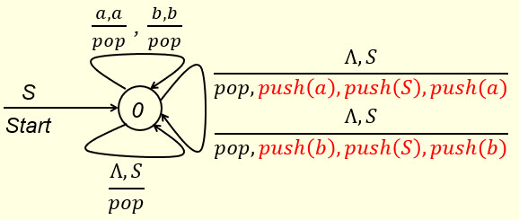
On the other hand, given such an one-state empty-stack acceptance PDA, we can convert it to a CFG. In this case, we have one type-4 path, three type-1 paths and two general type-3 paths. The type-4 and type-1 paths and their corresponding CFG productions are shown below.
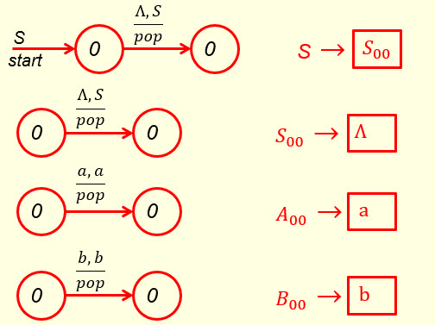
In the following, fill out the blanks in the general type-3 paths for $\frac{Λ, S}{pop, push\left(a\right), push\left(S\right), push(a)}$ and $\frac{Λ, S}{pop, push\left(b\right), push\left(S\right), push(b)}$ and the blanks in the corresponding CFG productions.

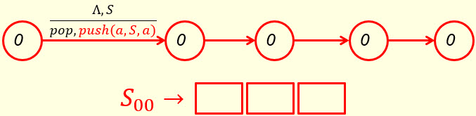

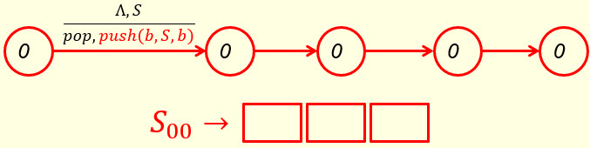

After a simple simplification process, we would get a CFG exactly the same as the given one.

- (1 point)
Final-state acceptance and empty-stack acceptance are equivalent only for NPDA’s. They are not equivalent for DPDA’s. For DPDA’s the class of languages defined by final-state acceptance is bigger. In the following, use the given DPDA

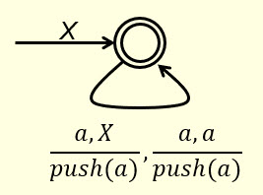

to show that this is indeed the case by pointing out the language L = { | n ϵ N } is accepted by the given (final-state) DPDA, but is not accepted by the DPDA when viewed as an empty-stack DPDA.

- (5 points)
Given the following final-state DPDA,
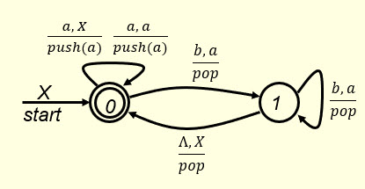

and the following strings

Ʌ, aa, bb, aaa, bbb, ab, ba, aabb, bbaa, aaabbb, bbbaaa

which of these strings are accepted by the given final-state DPDA? Put your answer in the following blank.

(1.5 points)

If the given final-state DPDA is considered as an empty-stack NPDA (state 0 is no longer a final state), then which of the given strings are accepted by the empty-stack DPDA? Put your answer in the following blank.

(1.5 points)

Now, consider the following two general questions. First, what is the language $L_{1}$ accepted by the given final-state DPDA? Put your answer in the following blank.

$L_{1}$ = (1 point)

Second, what is the language $L_{2}$ accepted by this DPDA when viewed as an empty-stack DPDA? Put your answer in the following blank.

$L_{2}$ = (1 point)

$L_{1}$ obviously is bigger than $L_{2}$.

- (5 points)
The following empty-stack PDA accepts the language L = { w ϵ {a, b}* | $n_{b}$(w) = 2$n_{a}$(w) } (assuming $Λ ∈L)$. In the following blanks show the execution of the string bbabab by this PDA.
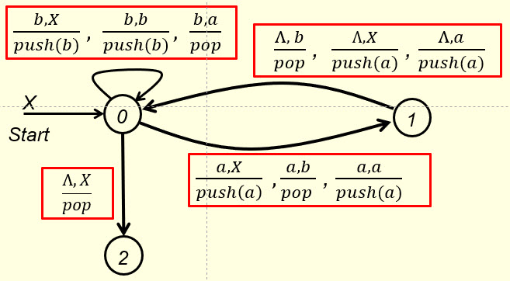

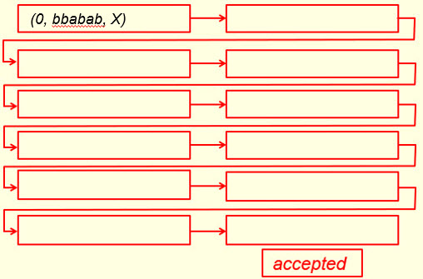

- (4 points)
The empty-stack PDA given in question #4 has one type 4, four type 1 and eight type 3 instructions. In the following four possible type 3 instructions, which one(s) are legitimate type 3 (i.e., they really exist)?
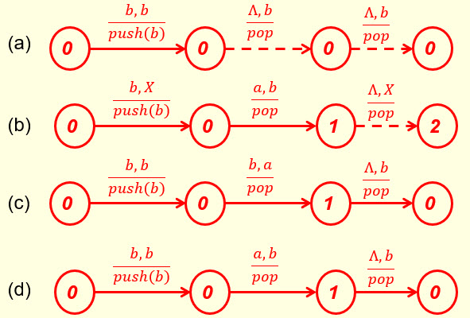

Put your answer in the following blank.

- (6 points)
Given the following parse tree where S, A, B are non-terminals, a and b are terminals and Ʌ is the empty string, show the corresponding left-most derivation of the yield in the blanks on the right side.

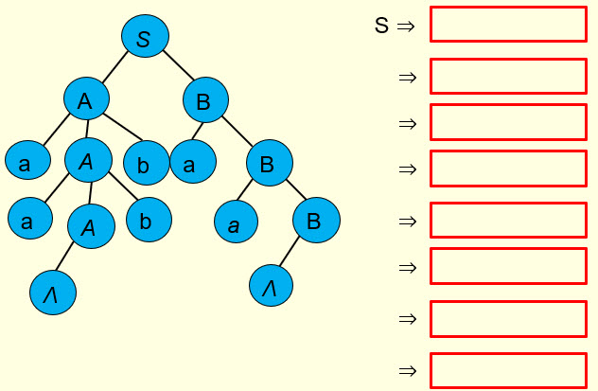 (4 points)

Does the derivation show the grammar is an LL(1) grammar?
Yes No (1 point)

Does the derivation show the grammar is an LL(2) grammar?
Yes No (1 point)

7. (2 points)
I claim the following grammar for {$a^{m+n}b^{m}c^{n}$ | m,n ϵ N} is an LL(1) grammar.

S → aSc | T T → aTb | Ʌ

My justification is that I can build a leftmost derivation for the string aaabcc by examining only one input symbol for each step of the derivation. The leftmost derivation is shown below.
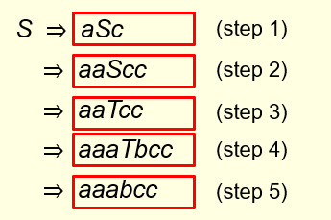
If you think the above derivation is correct, mark the True box below. Otherwise, mark the False box and give your reason in the box below the correct box.

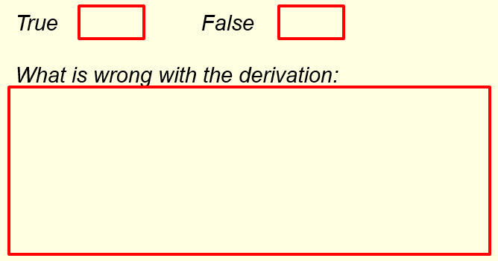

- (4 points)
Given the following context-free grammars for the language {$a^{m+n}b^{m}c^{n}$ | m,n ϵ N},
- S → aSc | aBb | Ʌ
B → aBb | Ʌ
- S → aSc | B | Ʌ
B → aBb | Ʌ
- S → aSc | B
B → aBb | Ʌ

- which one or ones are LL(1)? (2 points)

- which one or ones are ambiguous? (2 points)

- (4 points)
Given the following context-free grammars for the language {$a^{m+n}b^{m}c^{n}$ | m,n ϵ N}, which one or ones are LL(2) but not LL(1)?
- S → aaScc | aaBbc | aaBbb | aBb | ac | Ʌ
B → aBb | Ʌ
- S → aaScc | aaBbc | aBb | ac | Ʌ
B → aBb | Ʌ
- S → aaScc | aaBbc | B | ac | Ʌ
B → aBb | Ʌ
- S → aaScc | aaBbc | B | ac
B → aBb | Ʌ

- (3 points)

The language generated by the following grammar is (1 point)

S → aS | A | Ʌ A → abA | Ʌ

Is this an LL(1) grammar? Yes No (1 point)

Is this an LL(2) grammar? Yes No (1 point)

- Solutions must be typed (word processed) and submitted both as a pdf file and a word file to Canvas before 23:59 on 03/25/2024.
- Don’t forget to name your files as
CS375_2024s_HW6_LastName.docx / CS375_2024s_HW6_LastName.pdf

