CS375 Homework Assignment 10 (40 points)
Due date: 04/22/2024

- (12 points)
A TM that can perform multiplication on two positive unary numbers is developed based on the concept that “multiplication is extended addition”. For instance, $4×5$ can be viewed as the addition of five 4’s in unary form (see the first figure below). The process is to repeatedly perform addition on these five 4’s two at a time (in unary form; see the second and the third figures below) until four additions have been performed.

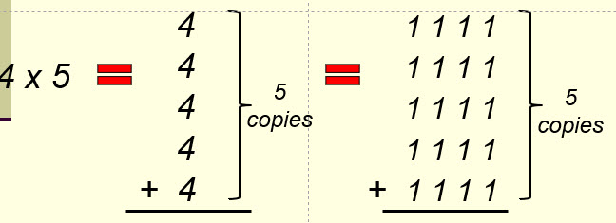

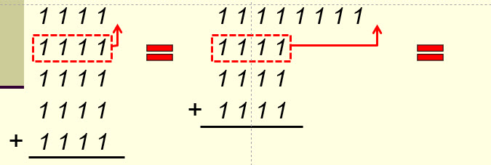

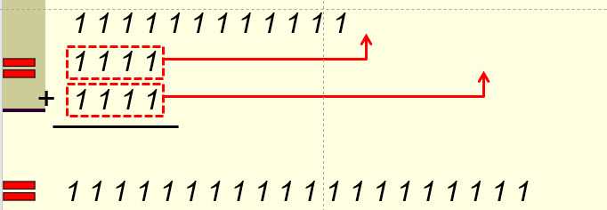

Your task here is to fill out the three blanks in the following TM that does multiplication of two given numbers m and n in unary form. Note that the portion circled by the red dotted curve is to perform the addition job (putting a copy of m 1’s at the end of n) and the portion circled by the blue dotted curve is the portion that does the counting (making sure n copies of m in unary form are put at the end of n.

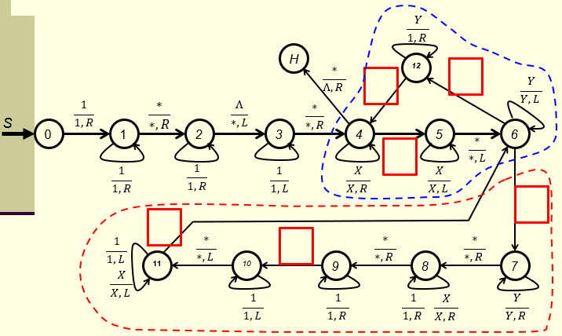

- (16 points)
A TM that can perform division on two positive unary numbers is developed based on the concept that “division is extended subtraction”. That concept and the implementation steps have been clearly described in the notes “Turing Machines and Equivalent Models-II’’. The main body of this TM is shown in the first figure below and the portions that perform Step 3 and Step 4 are shown in the second and the third figures separately. Your tasks here is to fill out the blanks in the second and the third figures so that these two portions can be connected to the proper nodes of the main body of the TM correctly.

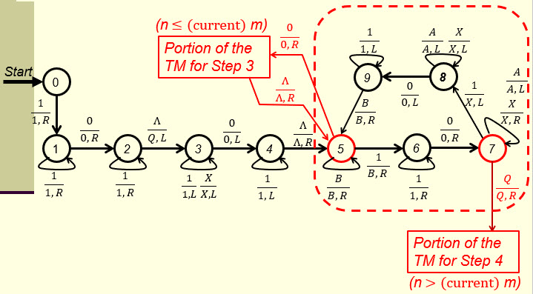

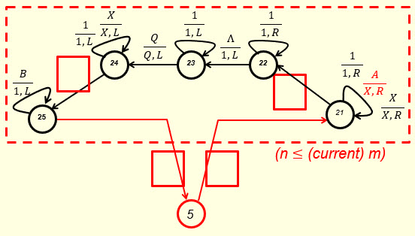

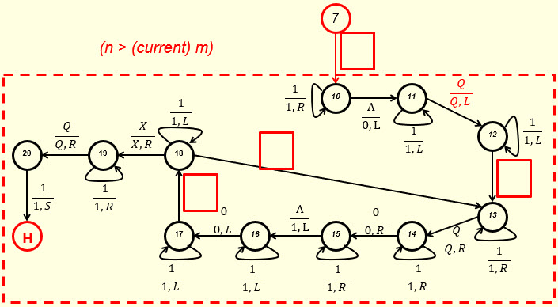

- (8 points)
The Church-Turing Thesis has two versions. The following is the second version:
Anything that is intuitively computable can be computed by a Turing machine.

The first version is shown below. Fill out the blue blank in the following box to make it a complete statement.

A problem can be solved by an if and only if it can be solved by a Turing machine.

(2 point)
The first version is an if and only if statement and the second version is not. Does this mean the other direction of the second version (‘Anything that can be computed by a Turing machine is intuitively computable’) is not true?

YES NO (2 point)

Justify your answer in the following text box.

(4 points)

- (4 points)
Church-Turing Thesis is not a theorem, but a thesis. Why? Put your answer in the following test box.

- Solutions must be typed (word processed) and submitted both as a pdf file and a word file to Canvas before 23:59 on 4/22/2024.
- Don’t forget to name your files as
CS375_2024s_HW10_LastName.docx / CS375_2024s_HW10_LastName.docx

